# **Practical – 3**

**Aim: 1. Construction of** **Discrete and** **continuous frequency distribution 2. Construction of Bar Diagram, Histogram, Pie Diagram, Frequency curve and Frequency polygon**

* Code for Discrete Frequency:

import pandas as pd

import matplotlib.pyplot as plt

import numpy as np

data_set = pd.read_csv("/content/drive/MyDrive/temp/dsc_data_prac_3.csv", nrows=11)

data_set.columns = ["Marks (out of 10)", "Number of Students (Frequency)"]

# it is necessary coz data is not properliy formatted then this will not work, plot function will crash

marks_numeric = data_set["Marks (out of 10)"]

fig, axes = plt.subplots(2, 3, figsize=(18, 10))

# ! bar chart

axes[0, 0].bar(data_set["Marks (out of 10)"], data_set["Number of Students (Frequency)"], color='blue', edgecolor='black')

axes[0, 0].set_xlabel("Marks (out of 10)")

axes[0, 0].set_ylabel("Number of Students (Frequency)")

axes[0, 0].set_title("Bar Chart of Marks Distribution")

# ! histgram

axes[0, 1].hist(data_set["Number of Students (Frequency)"], bins=6, color='purple', edgecolor='black')

axes[0, 1].set_xlabel("Number of Students (Frequency)")

axes[0, 1].set_ylabel("Frequency Count")

axes[0, 1].set_title("Histogram of Student Count")

# ! pie chart

axes[0, 2].pie(data_set["Number of Students (Frequency)"], labels=data_set["Marks (out of 10)"], autopct='%1.1f%%', colors=plt.cm.Set3.colors, startangle=140)

axes[0, 2].set_title("Pie Chart of Marks Distribution")

# ! curve chart

axes[1, 0].plot(marks_numeric, data_set["Number of Students (Frequency)"], marker='o', linestyle='-', color='red', label="Frequency Curve")

axes[1, 0].set_xlabel("Marks (out of 10)")

axes[1, 0].set_ylabel("Number of Students (Frequency)")

axes[1, 0].set_title("Frequency Curve")

axes[1, 0].grid(True)

axes[1, 0].legend()

# ! plygon

axes[1, 1].plot(marks_numeric, data_set["Number of Students (Frequency)"], marker='s', linestyle='--', color='blue', label="Frequency Polygon")

axes[1, 1].set_xlabel("Marks (out of 10)")

axes[1, 1].set_ylabel("Number of Students (Frequency)")

axes[1, 1].set_title("Frequency Polygon")

axes[1, 1].grid(True)

axes[1, 1].legend()

# Remove the last empty subplot (2,2)

fig.delaxes(axes[1, 2])

# ! removing the empty chart coz we made array of 3x3 and one was empty chart

plt.tight_layout()

plt.show()

* 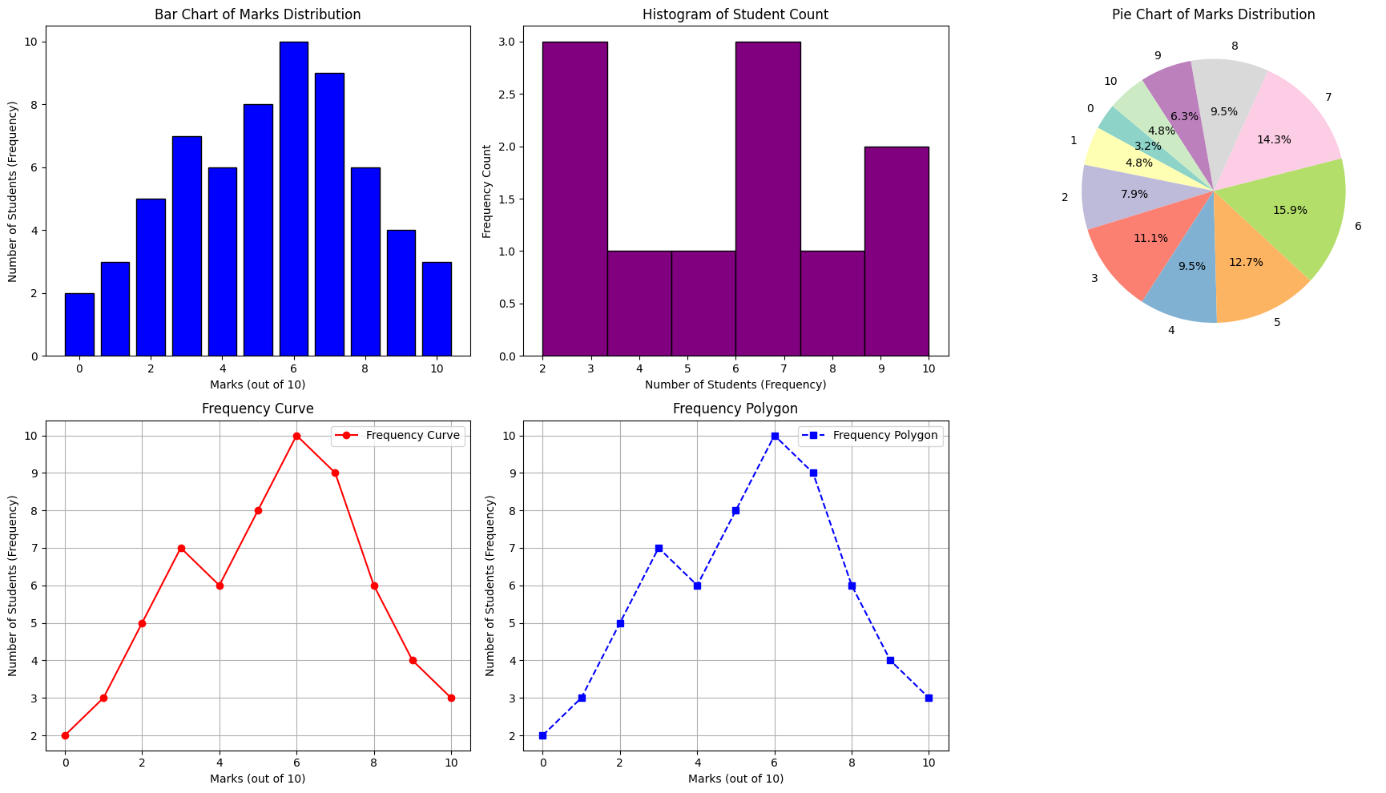Output of Discrete Frequency
* Code for continuous frequency distribution:

data_set = pd.read_csv("/content/drive/MyDrive/temp/dsc_data_prac_3.csv", skiprows=14)

data_set.columns = ["Hour of the Day", "Number of Vehicles (Frequency)"]

# ! we need int data coz hour col is in alphanumeric so histograms, curves, and polygons need data in int form

hours_numeric = np.arange(len(data_set))

# ! creating array for the plots

fig, axes = plt.subplots(2, 3, figsize=(18, 10))

# ! barchart

axes[0, 0].bar(data_set["Hour of the Day"], data_set["Number of Vehicles (Frequency)"], color='blue', edgecolor='black')

axes[0, 0].set_xlabel("Hour of the Day")

axes[0, 0].set_ylabel("Number of Vehicles (Frequency)")

axes[0, 0].set_title("Bar Chart of Vehicles per Hour")

axes[0, 0].tick_params(axis='x', rotation=45)

# ! histogram

axes[0, 1].hist(data_set["Number of Vehicles (Frequency)"], bins=6, color='purple', edgecolor='black')

axes[0, 1].set_xlabel("Number of Vehicles (Frequency)")

axes[0, 1].set_ylabel("Frequency Count")

axes[0, 1].set_title("Histogram of Vehicle Count")

# ! pie chart

axes[0, 2].pie(data_set["Number of Vehicles (Frequency)"], labels=data_set["Hour of the Day"], autopct='%1.1f%%', colors=plt.cm.Set3.colors, startangle=140)

axes[0, 2].set_title("Pie Chart of Vehicles per Hour")

# ! curve chart

axes[1, 0].plot(hours_numeric, data_set["Number of Vehicles (Frequency)"], marker='o', linestyle='-', color='red', label="Frequency Curve")

axes[1, 0].set_xticks(hours_numeric)

axes[1, 0].set_xticklabels(data_set["Hour of the Day"], rotation=45)

axes[1, 0].set_xlabel("Hour of the Day")

axes[1, 0].set_ylabel("Number of Vehicles (Frequency)")

axes[1, 0].set_title("Frequency Curve")

axes[1, 0].grid(True)

axes[1, 0].legend()

# ! polygon chart

axes[1, 1].plot(hours_numeric, data_set["Number of Vehicles (Frequency)"], marker='s', linestyle='--', color='blue', label="Frequency Polygon")

axes[1, 1].set_xticks(hours_numeric)

axes[1, 1].set_xticklabels(data_set["Hour of the Day"], rotation=45)

axes[1, 1].set_xlabel("Hour of the Day")

axes[1, 1].set_ylabel("Number of Vehicles (Frequency)")

axes[1, 1].set_title("Frequency Polygon")

axes[1, 1].grid(True)

axes[1, 1].legend()

# ! removing the empty chart coz we made array of 3x3 and one was empty chart

fig.delaxes(axes[1, 2])

plt.tight_layout()

plt.show()

* 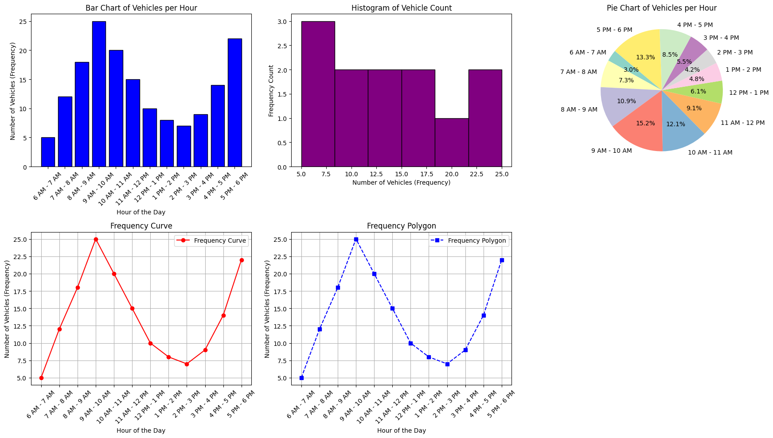Output of continuous frequency distribution:

Faculty Signature: _______________ Date: _____________________